Semi-automatic filling machine
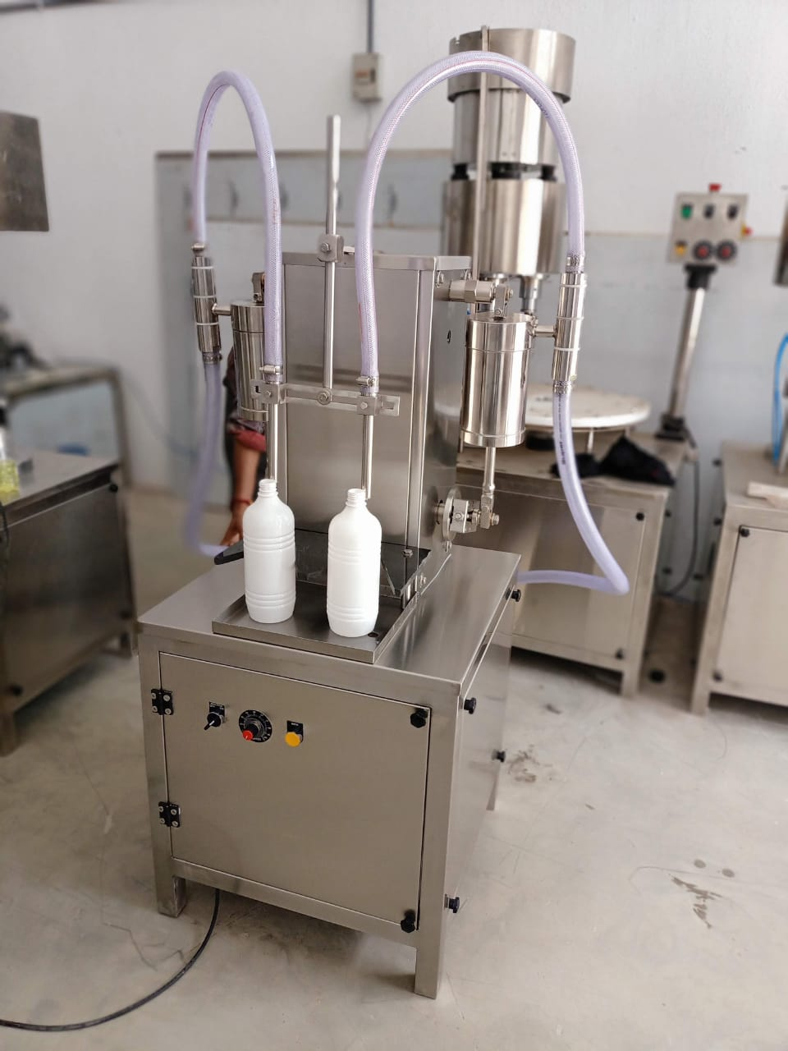
Description
Semi automatic volumetric liquid filling machine is precision built on sturdy welded MS frame completely enclose in stainless steel sheet and doors are provided to facilitate the servicing of machine. Working on volumetric principle, the unit is made compact, versatile and enclosed in stainless steel elegantly matt finish body.
Technical Specifications
Filling Range*** | 5 ml to 30 ml  50 ml to 250 ml  100 ml to 1000 ml
Output/Hour* | 900 to 1800*
Number Of Head / Syringe | 2 Nos.
Power Consumption | 1 HP / 415 V / 50 HZ
Machine Dimensions** | 500 mm (L) x 500 mm (W) x 1500 (H) Approx.
Net Weight | 130 kg. Approx.
Salient Features
- ±1 % Filling accuracy on single dose.
- Rigid vibration free construction for trouble free performance
- S.S. Elegantly matt finished body.
- A unit to fill variety of liquid and can be used for various types of containers.
- Total GMP model.

